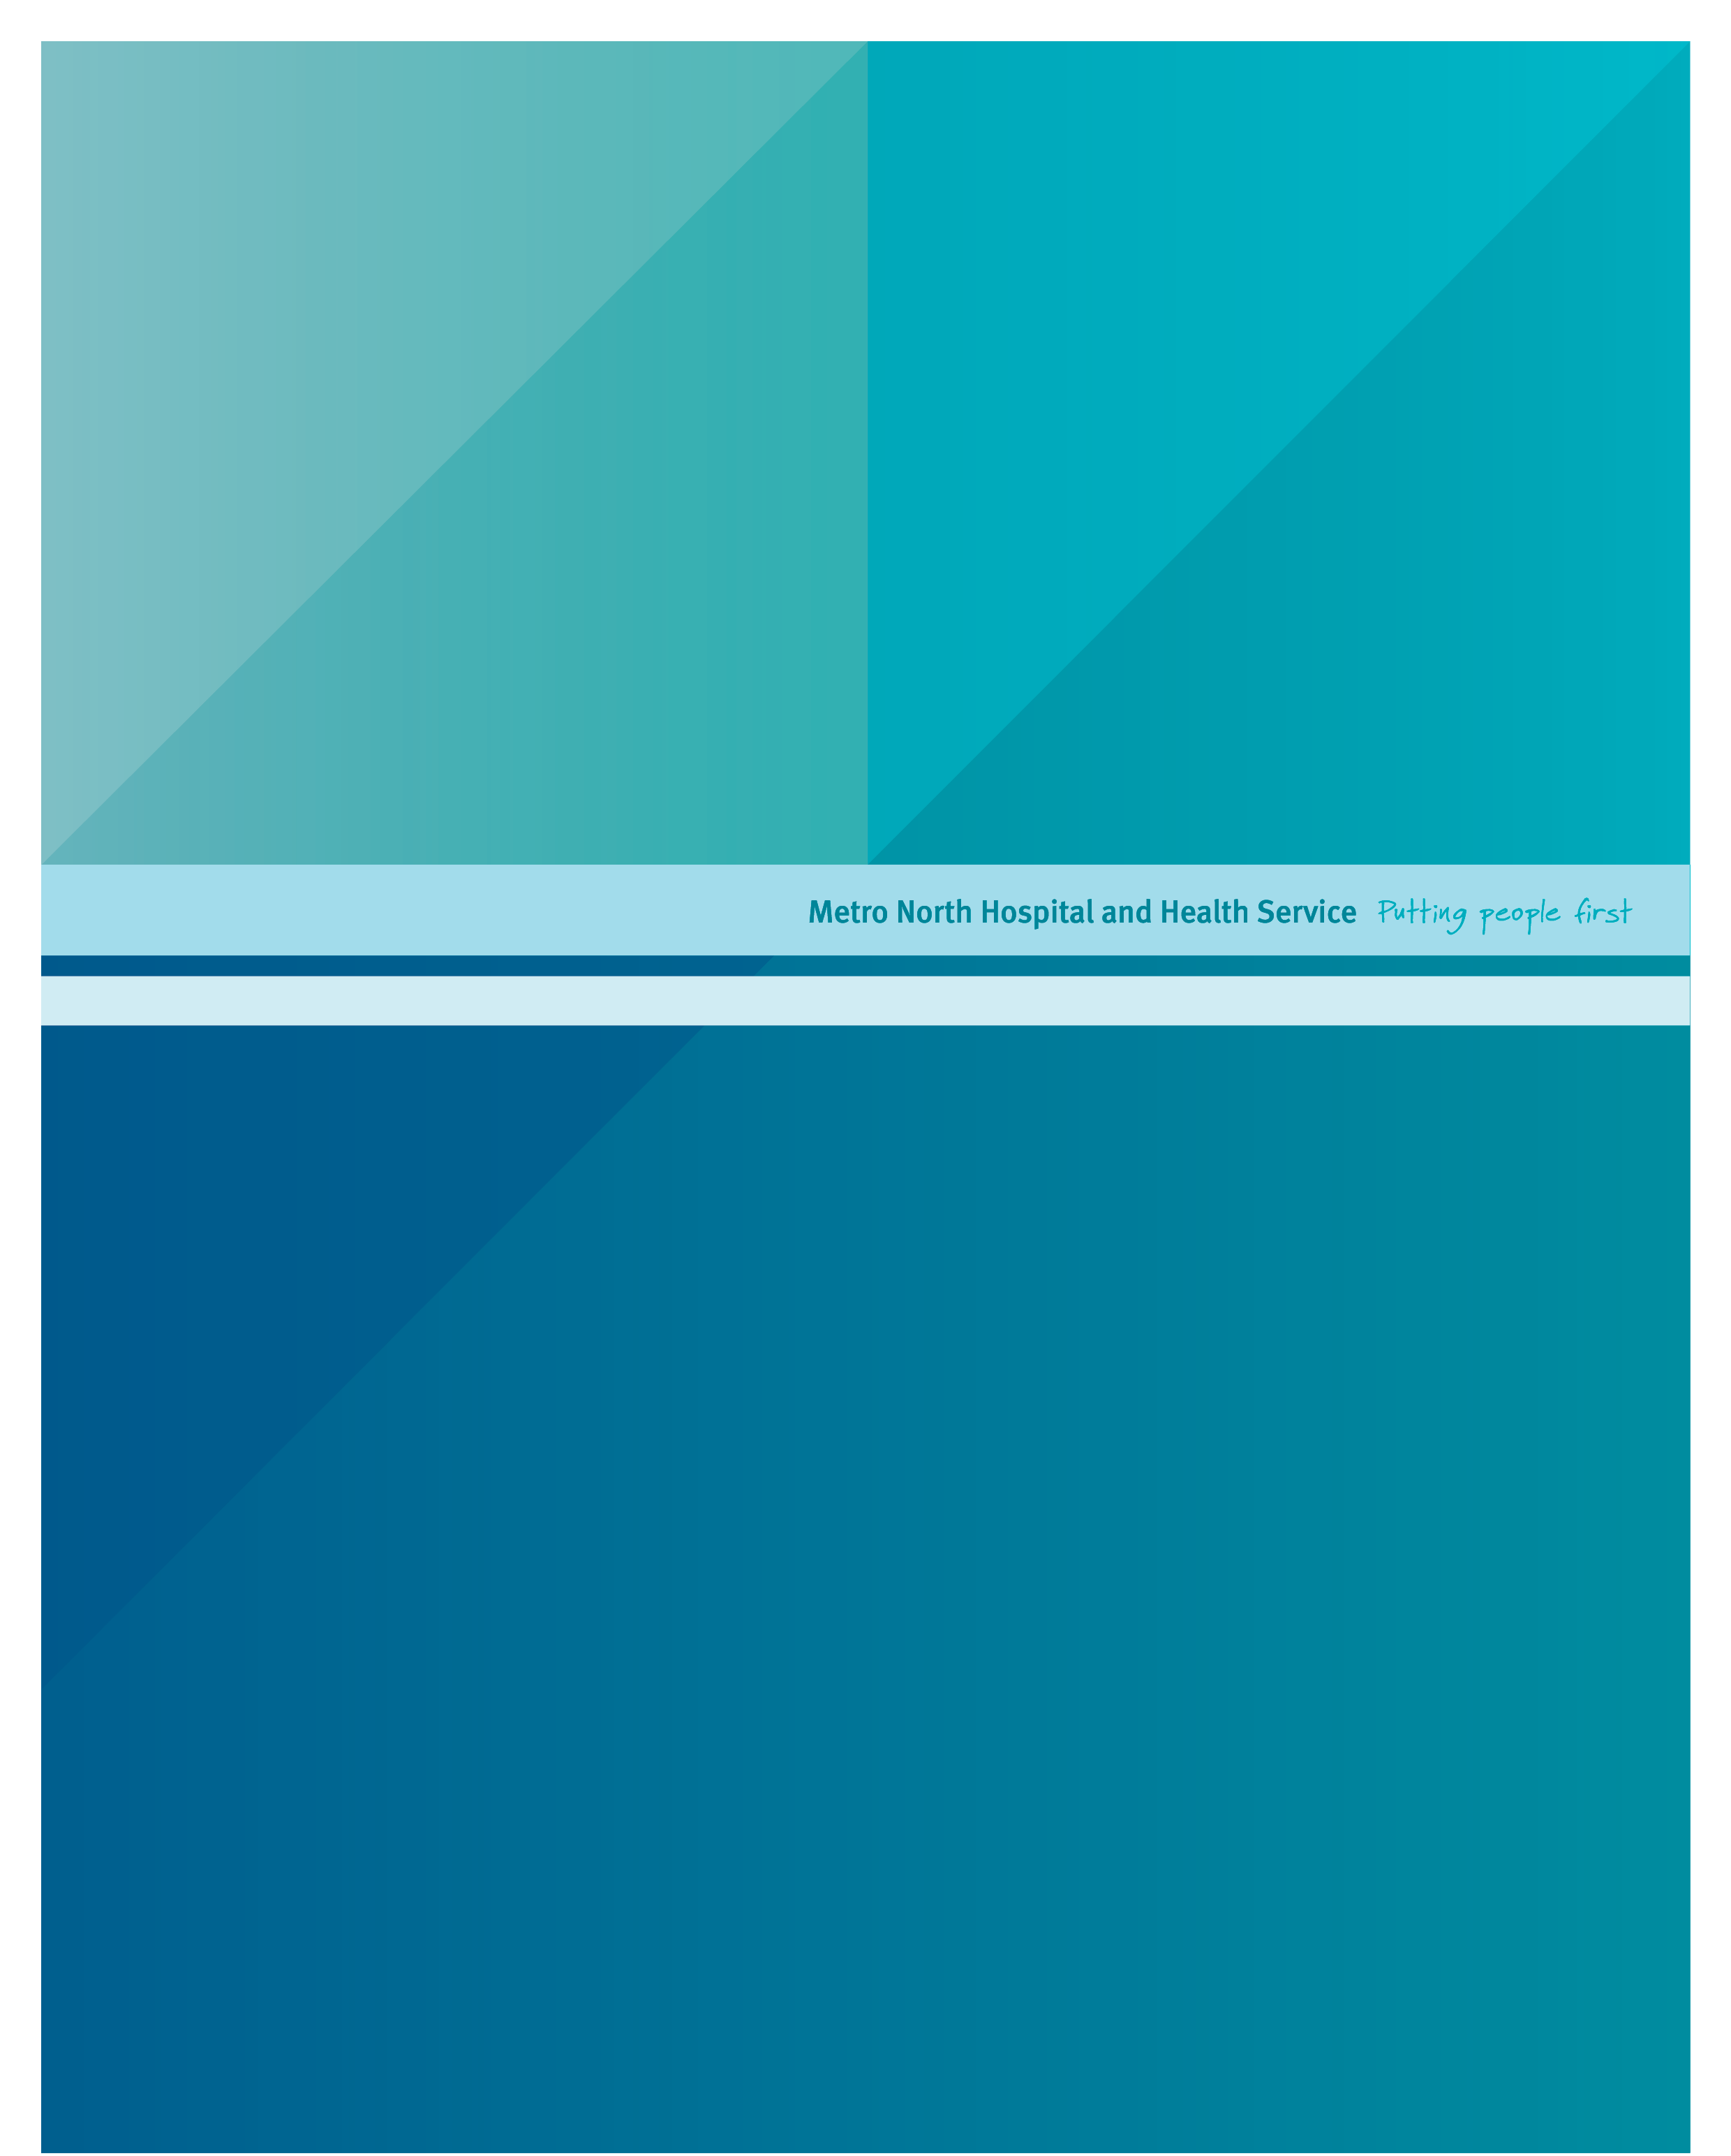
Herston Imaging Research Facility
Herston Imaging Research Facility – Project Support Scheme 2020: Guidance for Applicants

Published by the State of Queensland (Metro North Hospital and Health Service), March 2020
[IBNN or ISBN if needed]

This document is licensed under a Creative Commons Attribution 3.0 Australia licence.
To view a copy of this licence, visit creativecommons.org/licenses/by/3.0/au
© State of Queensland (Metro North Hospital and Health Service) 2018
You are free to copy, communicate and adapt the work, as long as you attribute the State of Queensland
(Metro North Hospital and Health Service).
For more information, contact:
Herston Imaging Research Facility, Metro North Hospital and Health Service, Level 3, UQCCR Building, RBWH Campus, Herston Queensland 4026, phone 07 3646 5818
Disclaimer:
The content presented in this publication is distributed by the Queensland Government as an information source only. The State of Queensland makes no statements, representations or warranties about the accuracy, completeness or reliability of any information contained in this publication. The State of Queensland disclaims all responsibility and all liability (including without limitation for liability in negligence) for all expenses, losses, damages and costs you might incur as a result of the information being inaccurate or incomplete in any way, and for any reason reliance was placed on such information.

Overview
HIRF initiated an exercise to pump-prime new research projects in 2015, repeating a similar exercise in 2018. To date, 342 hours of imaging time have been allocated to 15 projects. The 2016 scheme was a success with two of four supported projects going on to attract funding from external sources, a rate that meets expectations for a pilot scheme for blue sky ideas. The 2020 scheme seeks to capture new ideas for innovative use of imaging in medicine.
Reflecting the increasing role of collaboration at an early stage of innovation, this round of the scheme seeks to support ideas that are already able to demonstrate a link with state-wide, national or international research teams.

Support Available
- Imaging time on any of the HIRF instruments (3T Prisma MRI, PET-MR or PET-CT), defined by the specific scientific needs of the project
- Radiographer and standard project administrative support
- Advice and support with governance requirements
- For this round, we will be providing bespoke advice and support to research teams on the inclusion of imaging in bids to Medicine Research Futures Fund and other major translational grant schemes

The Scheme does not provide support for staff salaries or time. For this iteration of the Scheme, cash contributions for the use of molecular tracers or project costs (e.g. participant travel, consumables, publication costs) will not be provided. Applicants will need to demonstrate that they are able to provide sufficient staffing and logistic support to make the use of HIRF imaging time feasible within a stated timescale.

Renewal of Existing Projects
Investigators allocated imaging time in previous rounds, for projects that are yet to be completed, must apply for renewal of support. The same application form as for new applications must be used. The application form includes sections to describe progress to date and to describe plans to mitigate difficulties encountered.

Investigators with unfinished projects from previous rounds may apply for support for a revised or new project design. However, they must complete the renewal sections of the application form and explain how the new application relates to the previous application, including justification of feasibility.

Key Priorities
The central priority of this round of support will be creation or strengthening of links between HIRF and state-wide, national or international research teams. Priority will be given to applications that include the following features:
- Opportunity to participate in an approved multi-centre clinical trial
- Data acquisition with the purpose of joining a team preparing an application to the Medicine Research Futures Fund
- Opportunity for HIRF and affiliated researchers to join existing international consortia or teams
- Data acquisition with the purpose of joining a team preparing an application to the NHMRC Cohort or Clinical Trial schemes
- Projects able to demonstrate an existing co-contributing partner (e.g. commercial partnership)

Applicants will be asked to provide a clear and detailed explanation of how data collected with the support of HIRF will be used to pursue the objectives above.

To ensure equity, applications for renewal of support will also be asked to provide an explanation of how their project will meet this central priority.

Eligibility
- The Principal Applicant must hold a substantive appointment at a HIRF Alliance partner institution: Metro North Hospital and Health Service; University of Queensland; Queensland University of Technology; Queensland Institute for Medical Research.
- Project current or about to begin (within 3 months)
- The research team must include an investigator with an established track record in successful completion of imaging projects

Herston Imaging Research Facility
The Herston Imaging Research Facility (HIRF) is a purpose built multidisciplinary clinical translational research facility for providing superior diagnostic imaging services to Queensland researchers and clinicians. The facility is a collaboration between the Queensland Institute of Medical Research Berghofer (QIMRB), the Queensland University of Technology (QUT), the University of Queensland (UQ) and Metro North through the Royal Brisbane and Women’s Hospital (RBWH).

Our partnership of leading academic and health care institutions offers an exceptional opportunity to explore new pathways for improving the human condition. Providing Queensland researchers and clinicians with access to cutting-edge imaging technologies to observe disease processes in patients in vivo, will not only support meaningful reform in health care delivery, but place Queensland at the global frontier of human imaging research, clinical trials, and patient care.

HIRF’s imaging platform will comprises three modalities:

- MRI- 3 Tesla Magnetic Resonance Imaging scanner
- PET/CT- Positron Emission Tomography/Computed Tomography
- PET/MR Combined Synchronous

Currently the HIRF has capacity to provide more services than it is providing, and whilst it would be ideal for this to be funded research, we would rather have the scanners being used for research than not being used. This creates an opportunity to offer imaging or higher-level imaging to current (or about to commence) research projects, where an imaging component would significantly add benefit to the project. This offer does not replace imaging research which would have normally sought funding to be undertaken.

Application Process

Applications - for both new projects and renewals of existing support - should be made using the attached application form (also available on the HIRF website).

Applications should be emailed to HIRF_Operations@health.qld.gov.au. The application and all supporting documents should be sent as one PDF file where possible, and named: [Surname_2020HIRFProjectGrant_DocumentName.pdf]

The deadline for receipt of applications and all necessary supporting documents and enclosures is:

Friday 27th March 2020.

Late or incomplete applications will not be considered.

Additional Information
In the case of joining an existing trial or international team, a supporting letter from the lead investigator, detailing the purpose of the data to be collected and the future role of HIRF will be required.

In the case of future applications to MRFF or NHMRC, a minimum requirement will be a list of proposed CIs and precis of the proposed application, along with a letter of support from the proposed CIA.

Review of Applications
All applications will be checked for eligibility by the HIRF leadership team. Eligible applications will undergo independent peer review. Recommendations for support will be made by a panel, formed specifically for this round.

Ongoing Review and Project Milestones
Projects funded by the HIRF Project Support Scheme 2020 will be subject to ongoing review of progress. At the application stage, investigators will map out a project timeline and specific project milestones. Progress will be reviewed at 6 monthly intervals. In some cases, support may be withdrawn if projects fail to progress.

Further Information

Potential applicants are encouraged to discuss their application with either the Director, Prof Michael O’Sullivan, or Deputy Director, A/Prof Katie McMahon.

Contacts:
Prof Michael O’Sullivan
m.osullivan1@uq.edu.au
Ph: 3346 5503

A/Prof Katie McMahon
k21.mcmahon@qut.edu.au
Ph: 3346 6005

Application Form: HIRF Project Support Scheme 2020

PROJECT DETAILS

Project Title
Lead Applicant
Other Applicants

Project Outline
Maximum 500 words. Include number of scans for which support is requested. Include: research question; objectives; study design; significance to health.

Application Type
Place a cross in one of the boxes below
Medical Research Futures Fund collaboration
Collaboration with international consortium or trial
NHMRC Clinical Trial or Cohort Study
Project with co-contribution (e.g. commercial)
PLEASE ENSURE THAT APPROPRIATE SUPPORTING DOCUMENTS ARE PROVIDED, AS DETAILED IN THE GUIDANCE FOR APPLICANTS

HIRF Facilities
Specify which instrument: Prisma 3T MRI; PET-MR; PET-CT. Specify imaging requirements and sequences and radioligands to be used, as appropriate.

Investigator Imaging Track Record
Please describe the track record of the investigators specifically in biomedical imaging research. Note that it is a requirement of the Scheme that at least one investigator has a track record of successful completion of imaging projects, through to data analysis and publication. Maximum 500 words.

Previous Publications by Investigators
Please provide 5 selected publications. Ideally, publications should show the importance of the research question to health and illustrate the relevant experience of the research team.

Ethics and Governance
Ethics permission granted? | Yes/No
LREC reference number
RBWH governance permission granted? | Yes/No
SSA reference number

PROGRESS AND MILESTONES

Progress to Date (Renewal applications only)
Summarise objectives and proposed milestones from the initial application – and progress against these milestones. Maximum 500 words.

Difficulties and Contingency Plans (Renewal applications only)
If progress has been hampered by specific obstacles, please describe these briefly along with current plans to overcome them. Maximum 500 words.

Project milestones (ALL applications)
Please provide specific milestones and dates on which they are to be achieved. Include details of the proposed start date of scanning at HIRF, rate of recruitment, and proposed end date.

Future Research Plans (ALL applications)
Please describe in detail how the data acquired through this scheme will be used to support either engagement in existing collaborative studies or applications for major funding. Where grant applications are proposed, please provide details as a separate attachment (see Guidance for Applicants)

For applications based on co-contribution, please detail the co-contribution here.

Approved multi-centre clinical trial is defined as a study meeting the WHO definition of clinical trial, for which appropriate funding and ethical permission and apparent feasibility at this site can be confirmed at the time of application.

